|  |  |  |
| --- | --- | --- |
| **Name: GAURAV MAHAJAN** | **SRN: PES1UG20CS150** | **Section: C** |
| **Date: 02-02-2022** | **WEEK 2** |

**Task 1 (Demo)**

**Network Topology:**

To replicate given scenario, create a topology in packet tracer, as shown in following image.

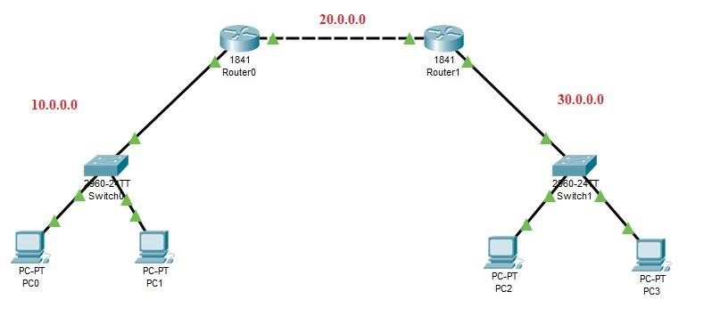

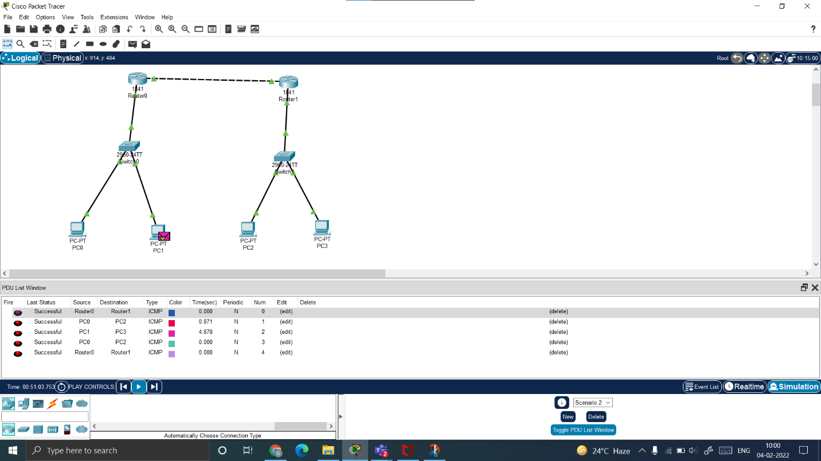

**Task 2 (Mandatory for Week-6)**

